$() – shortcut to call the jquery function

$.get() – invokes the helper function of get in jquery

CSS

#para 1 { text-align: center; color: red; }

Selector declaration

# <- id

. <- .class

Any element can be used as a selector

Pseudo classes (link) they’re predetermined for each element (a is for links)

a:link { color: #FF0000; } /* unvisited link */

pseudo class (visited). Links with class “red” applies to this

a.red:visited

/*format first letter of all p elements*/

p::first-letter { color: #ff0000;

font-size: xx-large; }

combining pseudo elements

p::first-letter{color:#ff0000; font-size:xx-large;}  
p::first-line{color:#0000ff; font-variant:small-caps;}

First letter of the p will be red, xx-large.

The rest of the first line will be blue, small-caps.

**XSD**

<!ELEMENT books (book+)>

<!ELEMENT book (title, author, year, price)>

<!ELEMENT title (#PCDATA)>

<!ELEMENT author (#PCDATA)>

<!ELEMENT imageurl (#PCDATA)>

<!ELEMENT price (#PCDATA)>

<!ELEMENT publicationdate (#PCDATA)>

<!ELEMENT publisher (#PCDATA)>

<!ATTLIST book type CDATA "category">

Starts with root, and moves in

Describing each element one at a time

#PCDATA - Parsed character data (means required)

Atlist is attribute list

CDATA = not being parsed, can exist but not mandatory

Android lifecycle (onCreate) etc

Javascript

DOM - Document Object model

Interpreter vs compiler

Line by line. Error only found when executed

Compiler – finds glaring errors during compile time

Javascript – web browser acts as the interpreter

Type inferenced – var instead of (int, string etc very much like python)

Function name(parameters) {

}

== string

=== same object and same value

var strin30= “30”

+string30 -> turns it into a number

Jquery - .ready (when the web page is ready, something is run)

$(“#inputBox”) same as document.getElementById(“inputBox”)

$(“p #inputBox”)

Blurr vs focus

Focus on an object its being selected on the page

.blurr event when you leave the object. We can get the object that we just used. We can quickly validate the input

api.jquery.com

: pseudo classes

like hover

:: pseudo elements

like first-letter

+adjacent

~sibilings

> child

float - is like through when inserting images

absolute is positioned (any element except static) relative to the nearest positioned ancestor.

XPath

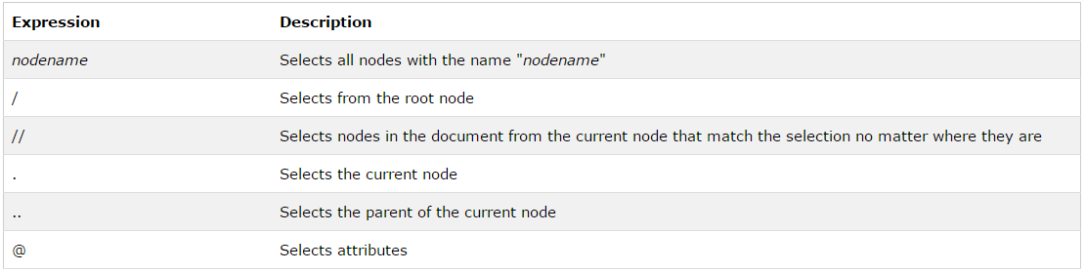

Examples –

Predicates are used to find a specific node or a node that contains a specific value.

Predicates are always embedded in square brackets.

In the table below we have listed some path expressions with predicates and the result of the expressions: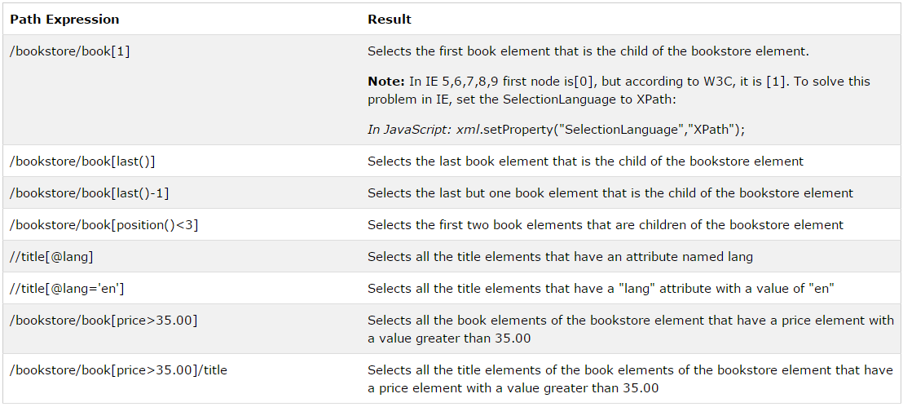

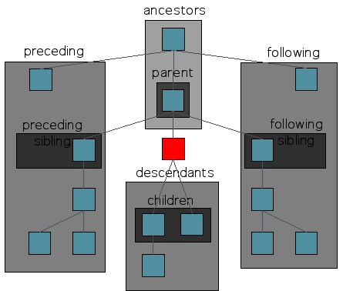

.on

.get

.oncreate

.html

.load

.append

document - refers to the document itself

window - refers to the browser

Javascript Object Notation

lighter than xml

used temporarily to transfer data

just a data format

easily readable and simple

.stringify

.parse()

https://developer.mozilla.org/en/docs/Web/JavaScript/Reference/Global_Objects/JSON/stringify

JSON.stringify(value[, replacer[, space]])

replacer ( takes either a function with two parameters (key, value) or an array)

filters out what to keep and what to throw out (only keeps the things in the array or those returned by the function)

space - number of indent space

xpath

position()<3 //returns the first 2 child nodes

concat(xpath, 'string', xpath)

matches(attribute, 'stringtomatch')

contains(attribute, 'containsthisstring')

startswith(attribute, 'string')]

string-length('string')

count - number of occurances

-need to study-

c++

a little on ai and network security

ssl protocol

transport layer security